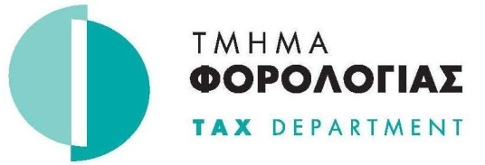

ANNOUNCEMENT

FATCA data validation

The Cyprus Tax Department informs all Reporting Financial Institutions that have reported under the FATCA intergovernmental agreement that has finished with the XML file validation. The results are available in each institution’s Tax Department FTP account.

Please proceed with any required corrections as soon as possible and not later of 15/09/2015.

The corrected file to be submitted will fully replace any previously submitted file and should use a new name as this is described in the respective user guide.

TAX DEPARTMENT
11/09/2015

Φακ. : 05.14.001, 03.10.002

